CARLOW VINTAGE AND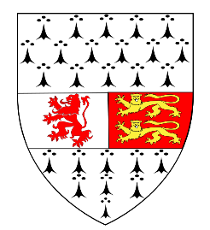
CLASSIC MOTOR CLUB.
Membership form 2018
Name*________________________________________
Address*______________________________________
______________________________________________
Telephone No.*_________________________________
Mobile No*____________________________________
Email Address*_________________________________
Received by*___________________________________
Date*_________________________________________
Car Make and Model*____________________________
Signature of Applicant*___________________________
How did you hear about the club?
- Friend
- Internet
- Other
MEMBERSHIP:
- Individual Membership €25:00
- Family Membership €35:00
*Denotes a required field that must be filled out, Please note your application must have the date filled in.
Official use only
Received by: ______________________________ Postal Address: James Lakes
Approved by: _____________________________ Upper Seskin
Date received: ____________________________ Leighlinbridge
Membership Number: ______________________ Co. Carlow
Signed: __________________________________
Date: ____________________________________

